BLOCKCHAIN DEVELOPMENT — TOOL ORIENTATION LAB
Getting to Know Your
Developer Toolkit
Hardhat • MetaMask • Etherscan • Web3.js • React

A complete hands-on orientation to the full Ethereum development stack

⚒  Hardhat  Compile, test & deploy contracts | 🦊  MetaMask  Your wallet & identity | 🔍  Etherscan  Explore the blockchain | 🌐  Web3.js  Talk to contracts from JS | ⚛️  React  Build the frontend UI

🎯 Level  Beginner — Step by step | ⏱ Duration  3 – 4 Hours | 🛠 Prerequisites  Node.js v18+ | 🌐 Network  Ethereum Sepolia

OVERVIEW HOW ALL FIVE TOOLS WORK TOGETHER

This lab walks you through the complete Ethereum development workflow — from writing and testing a contract locally, deploying it to a public testnet, reading it on Etherscan, and finally building a React web app that lets anyone interact with it through a browser.

The Full Stack at a Glance

# | Tool | Role in This Lab
1 | Hardhat | Write Counter.sol, compile, run tests, deploy to Sepolia
2 | MetaMask | Wallet for signing deployment and write transactions
3 | Etherscan | Verify source code, inspect transactions, call functions
4 | Web3.js | Read contract state and send transactions from JavaScript
5 | React + Vite | Build a live web UI connected to the deployed contract

Lab Sections

Part |  | Topic | Outcome
Part 1 |  | MetaMask | Wallet set up, Sepolia added, test ETH received
Part 2 |  | Hardhat | Project scaffolded, Counter.sol written, deployed to Sepolia
Part 3 |  | Etherscan | Contract verified, transactions read, functions called from browser
Part 4 |  | Web3.js | Counter read and written via JavaScript in Node.js console
Part 5 |  | React + Web3.js | Full React DApp deployed to Vercel/Netlify
📌 NOTE
Parts 1–3 should feel familiar if you have done the Tool Orientation Lab. Parts 4 and 5 are new — they build the Web3.js and React frontend on top of the same Counter contract you deployed in Part 2.

PART 1 METAMASK — WALLET SETUP

MetaMask is your wallet and identity on the blockchain. Every transaction you send — deploying a contract, calling a function — is signed by MetaMask before it reaches the network.

Setup Checklist

1 | Install MetaMask  - Go to https://metamask.io and install the browser extension  - Click Get Started → Create a new wallet  - Set a strong password and write down your 12-word Secret Recovery Phrase  🛑 STOP  NEVER share your Secret Recovery Phrase. Anyone who has it can take all your funds. Store it offline on paper.

2 | Add Sepolia Testnet  - Click the network dropdown → Add Network → Add a network manually  Field Value  Network Name Sepolia Testnet  New RPC URL https://rpc.sepolia.org  Chain ID 11155111  Currency Symbol ETH  Block Explorer URL https://sepolia.etherscan.io

3 | Get Sepolia Test ETH  Visit one of these faucets and paste your wallet address:  - https://sepoliafaucet.com  - cloud.google.com/application/web3/faucet/ethereum/sepolia  - https://www.infura.io/faucet/sepolia  💡 TIP  You need at least 0.1 Sepolia ETH. Wait 1–2 minutes then check your MetaMask balance on Sepolia.

4 | Export Your Private Key  Hardhat needs your private key to sign deployment transactions:  - MetaMask → click ⋮ next to your account → Account Details → Show Private Key  - Enter your password, copy the 64-character hex key (starts with 0x)  - You will paste this into .env in Part 2 — never share it or commit it to Git

What to Look For | Your Observation
Your MetaMask wallet address (0x…) | 3fc21f219f43914ccc8537badc55d3bbd1ed141b21babba6b092fe132ae49fcc
Sepolia ETH balance after faucet | 0.0893SepoliaETH
Network name shown in MetaMask dropdown | Sepolia

PART 2 HARDHAT — PROJECT SETUP & DEPLOYMENT

Hardhat is your local Ethereum development environment. You write contracts here, test them, and deploy them to any network.

Activity 2.1 — Scaffold the Project

1 | Create and Initialize the Project  1 mkdir counter-dapp  2 cd counter-dapp  3 npm init -y  4 npm install --save-dev hardhat @nomicfoundation/hardhat-toolbox  5 npm install dotenv  6 npx hardhat --init  When prompted: select Create a JavaScript project → press Enter for all prompts → y for dependencies. If errors were encountered, use this fix: npm install --save-dev hardhat@^2.28.0

2 | Configure hardhat.config.js  Replace the entire contents of hardhat.config.js with:  1 require("@nomicfoundation/hardhat-toolbox");  2 require("dotenv").config();  3  4 module.exports = {  5 solidity: "0.8.24",  6 networks: {  7 hardhat: {},  8 localhost: {  9 url: "http://127.0.0.1:8545",  10 },  11 sepolia: {  12 url: process.env.SEPOLIA_RPC_URL || "",  13 accounts: process.env.PRIVATE_KEY  14 ? [process.env.PRIVATE_KEY] : [],  15 },  16 },  17 etherscan: {  18 apiKey: process.env.ETHERSCAN_API_KEY || "",  19 },  20 };

3 | Create the .env File  In the project root, create .env:  1 # .env — NEVER commit this file to Git  2 SEPOLIA_RPC_URL=https://eth-sepolia.g.alchemy.com/v2/YOUR_KEY  3 PRIVATE_KEY=0xYOUR_METAMASK_PRIVATE_KEY  4 ETHERSCAN_API_KEY=YOUR_ETHERSCAN_API_KEY  💡 TIP  Get a free Alchemy RPC URL at https://www.alchemy.com — create an app for Ethereum Sepolia. Get a free Etherscan API key at https://etherscan.io/register → My Profile → API Keys.

Activity 2.2 — Write Counter.sol

4 | Create the Smart Contract  Delete contracts/Lock.sol then create contracts/Counter.sol:  1 // SPDX-License-Identifier: MIT  2 pragma solidity ^0.8.0;  3  4 /// @title Counter — simple on-chain counter for the DApp lab  5 contract Counter {  6 uint256 public count;  7 address public owner;  8 uint256 public stepSize;  9  10 event CountIncremented(address indexed by, uint256 newCount);  11 event CountReset(address indexed by);  12 event StepSizeChanged(uint256 oldStep, uint256 newStep);  13 event Milestone(uint256 count);  14  15 modifier onlyOwner() {  16 require(msg.sender == owner, "Not the owner");  17 _;  18 }  19  20 constructor(uint256 _startCount, uint256 _stepSize) {  21 count = _startCount;  22 stepSize = _stepSize;  23 owner = msg.sender;  24 }  25  26 function increment() public {  27 count += stepSize;  28 emit CountIncremented(msg.sender, count);  29 if (count % 10 == 0) {  30 emit Milestone(count);  31 }  32 }  33  34 function incrementBy(uint256 _amount) public {  35 require(_amount > 0, "Amount must be positive");  36 count += _amount;  37 emit CountIncremented(msg.sender, count);  38 }  39  40 function reset() public onlyOwner {  41 count = 0;  42 emit CountReset(msg.sender);  43 }  44  45 function setStepSize(uint256 _newStep) public onlyOwner {  46 require(_newStep > 0, "Step must be positive");  47 emit StepSizeChanged(stepSize, _newStep);  48 stepSize = _newStep;  49 }  50  51 function hasReachedTarget(uint256 _target)  52 public view returns (bool)  53 {  54 return count >= _target;  55 }  56 }

5 | Compile and Test  1 Before compiling execute the following: npm install --save-dev "@nomicfoundation/hardhat-toolbox@hh2" npx hardhat compile  2 npx hardhat test  Expected: Compiled 1 Solidity file successfully. The sample Lock tests may also run — that is fine.  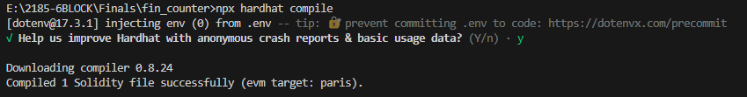  📌 NOTE  After compiling, check artifacts/contracts/Counter.sol/Counter.json — this file contains the ABI you will need for Web3.js and React.

6 | Create the Ignition Deployment Module  Delete ignition/modules/Lock.js then create ignition/modules/Counter.js:  1 const { buildModule } = require(  2 '@nomicfoundation/hardhat-ignition/modules'  3 );  4  5 module.exports = buildModule('CounterModule', (m) => {  6 // Deploy Counter(startCount=0, stepSize=1)  7 const counter = m.contract('Counter', [0, 1]);  8 return { counter };  9 });

7 | Deploy to Sepolia  1 npx hardhat ignition deploy ignition/modules/Counter.js  2 --network sepolia  Wait 15–60 seconds. Note the deployed address from the output:  1 [ CounterModule ] successfully deployed 🚀  2  3 Deployed Addresses  4 CounterModule#Counter - 0xYOUR_CONTRACT_ADDRESS_HERE  📝 RECORD  Copy and save this address. You will use it in Parts 3, 4, and 5.  What to Look For Your Observation  Deployed Counter address 0xA19cC6cF0EE0248acDc97933cb998a7e8730C03F  Deployment transaction hash (check MetaMask Activity)  Sepolia ETH balance remaining after deployment 0.4702SepoliaETH

PART 3 ETHERSCAN — VERIFY, INSPECT & INTERACT

Etherscan is the blockchain's public ledger reader. Once your contract is verified here, anyone can read its source code, call view functions, and send write transactions — all from a browser.

Activity 3.1 — Verify Your Contract

1 | Run the Verification Command  Replace 0xYOUR_COUNTER_ADDRESS with your actual deployed address:  1 # The '0 1' are constructor arguments: startCount=0, stepSize=1  2 npx hardhat verify --network sepolia  3 0xYOUR_COUNTER_ADDRESS 0 1  Successful output:  1 The contract 0xYOUR_COUNTER_ADDRESS has been verified on Etherscan.  2 https://sepolia.etherscan.io/address/0xYOUR_COUNTER_ADDRESS#code  💡 TIP  If you see 'Already Verified', the contract was already submitted. Navigate to Etherscan to confirm the green checkmark appears on the Contract tab.
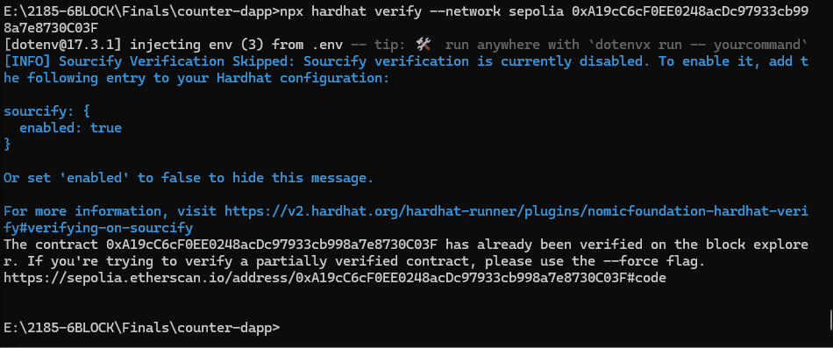

Activity 3.2 — Explore and Interact

2 | Read the Contract on Etherscan  - Go to https://sepolia.etherscan.io and paste your contract address  - Click Contract tab → Read Contract sub-tab  - Expand count, owner, stepSize  What to Look For Your Observation  count value 0 uint256  owner address 0x0929e5440C08AA09bB30dab91CA5850Fb078c96E address  stepSize value 1 uint256  Does owner match your MetaMask address? No

3 | Send a Transaction from Etherscan  - Click Write Contract sub-tab → Connect to Web3  - MetaMask pops up — click Connect  - Expand increment → click Write  - Confirm in MetaMask, wait ~15 seconds  - Go back to Read Contract → check count again  What to Look For Your Observation  count BEFORE increment 0 uint256  count AFTER increment 0 uint256  Transaction hash of the increment call 0x2c9e715466f17705bd8102c7394b687feb8907ade3a95cecb10d8bc3786cb879

4 | Read an Event Log  - On your contract page, click the Events tab  - Expand the most recent CountIncremented event  What to Look For Your Observation  'by' parameter (address that called increment) 0x0929e5440C08AA09bB30dab91CA5850Fb078c96E  'newCount' parameter  Matches your MetaMask address? Yes

Q1 | Verifying a contract publishes its Solidity source code on Etherscan. What would users only see if you did NOT verify the contract? What risk does unverified bytecode create for users?
Q2 | Etherscan's Write Contract tab let you call increment() without writing any code. Is this convenient or a security concern? What prevents a malicious person from calling reset() on your contract?

PART 4 WEB3.JS — TALKING TO YOUR CONTRACT FROM JAVASCRIPT

Web3.js is the most widely used JavaScript library for interacting with Ethereum. In this part you will use it directly in Node.js to read your Counter contract and send transactions — without any UI. This is the foundation for Part 5 where you connect it to React.

What Is Web3.js?

Concept | Explanation
Web3.js | A JavaScript library that sends JSON-RPC calls to an Ethereum node on your behalf
JSON-RPC | The protocol Ethereum nodes speak. Web3.js wraps it in clean JS functions.
Provider | The connection to the network — either an RPC URL or the MetaMask browser object
Contract instance | A JS object that mirrors your contract. Call .methods.fn().call() to read, .send() to write.
ABI | The 'menu' of your contract. Web3.js needs it to know what functions exist.

🌐 WEB3.JS
Web3.js communicates with Ethereum through a Provider. For reading, any public RPC URL works. For writing (transactions), you need a wallet — either a private key in Node.js or MetaMask in the browser.

Activity 4.1 — Install Web3.js and Read the Contract

1 | Install Web3.js in the Project  In your counter-dapp folder, install Web3.js:  1 npm install web3  Verify installation:  1 node -e "const {Web3} = require('web3'); console.log('Web3 version:', Web3.version)"

2 | Copy the ABI from Hardhat Artifacts  The ABI was generated when you compiled the contract. Find it at:  1 artifacts/contracts/Counter.sol/Counter.json  Create a helper file scripts/abi.js that exports just the ABI array:  1 // scripts/abi.js  2 // Copy the 'abi' array from Counter.json here:  3 const COUNTER_ABI = [  4 {"inputs":[{"name":"_startCount","type":"uint256"},  5 {"name":"_stepSize","type":"uint256"}],  6 "stateMutability":"nonpayable","type":"constructor"},  7 {"anonymous":false,"inputs":[  8 {"indexed":true,"name":"by","type":"address"},  9 {"indexed":false,"name":"newCount","type":"uint256"}],  10 "name":"CountIncremented","type":"event"},  11 {"anonymous":false,"inputs":[  12 {"indexed":true,"name":"by","type":"address"}],  13 "name":"CountReset","type":"event"},  14 {"anonymous":false,"inputs":[  15 {"indexed":false,"name":"count","type":"uint256"}],  16 "name":"Milestone","type":"event"},  17 {"inputs":[],"name":"count",  18 "outputs":[{"type":"uint256"}],"stateMutability":"view","type":"function"},  19 {"inputs":[],"name":"owner",  20 "outputs":[{"type":"address"}],"stateMutability":"view","type":"function"},  21 {"inputs":[],"name":"stepSize",  22 "outputs":[{"type":"uint256"}],"stateMutability":"view","type":"function"},  23 {"inputs":[],"name":"increment",  24 "outputs":[],"stateMutability":"nonpayable","type":"function"},  25 {"inputs":[{"name":"_amount","type":"uint256"}],"name":"incrementBy",  26 "outputs":[],"stateMutability":"nonpayable","type":"function"},  27 {"inputs":[],"name":"reset",  28 "outputs":[],"stateMutability":"nonpayable","type":"function"},  29 {"inputs":[{"name":"_newStep","type":"uint256"}],"name":"setStepSize",  30 "outputs":[],"stateMutability":"nonpayable","type":"function"},  31 {"inputs":[{"name":"_target","type":"uint256"}],"name":"hasReachedTarget",  32 "outputs":[{"type":"bool"}],"stateMutability":"view","type":"function"}  33 ];  34  35 module.exports = { COUNTER_ABI };  💡 TIP  Tip: Instead of copying manually, you can import directly: const { abi } = require('../artifacts/contracts/Counter.sol/Counter.json'). Both approaches work.

3 | Read Contract State with Web3.js  Create scripts/read-counter.js:  1 // scripts/read-counter.js  2 // Run with: node scripts/read-counter.js  3  4 const { Web3 } = require("web3");  5 require("dotenv").config();  6 const { COUNTER_ABI } = require("./abi");  7  8 // ── Configuration ─────────────────────────────────────────────  9 const RPC_URL = process.env.SEPOLIA_RPC_URL;  10 const CONTRACT = '0xYOUR_COUNTER_ADDRESS'; // paste your address  11  12 async function main() {  13 // Connect Web3.js to Sepolia via the RPC URL  14 const web3 = new Web3(RPC_URL);  15  16 // Create a contract instance (read-only — no wallet needed)  17 const counter = new web3.eth.Contract(COUNTER_ABI, CONTRACT);  18  19 // Read state variables — .call() is free, no gas needed  20 const count = await counter.methods.count().call();  21 const owner = await counter.methods.owner().call();  22 const stepSize = await counter.methods.stepSize().call();  23  24 console.log('=== Counter Contract State ===');  25 console.log('Contract address:', CONTRACT);  26 console.log('count: ', count.toString());  27 console.log('owner: ', owner);  28 console.log('stepSize:', stepSize.toString());  29  30 // Call a view function with a parameter  31 const reached = await counter.methods  32 .hasReachedTarget(10).call();  33 console.log('Has reached 10?', reached);  34  35 // Read the contract's ETH balance (should be 0 — no payable fns)  36 const bal = await web3.eth.getBalance(CONTRACT);  37 console.log('Contract ETH balance:', web3.utils.fromWei(bal,'ether'), 'ETH');  38 }  39  40 main().catch(console.error);  Run it:  1 node scripts/read-counter.js  What to Look For Your Observation  count value printed  owner address printed  stepSize value  hasReachedTarget(10) result
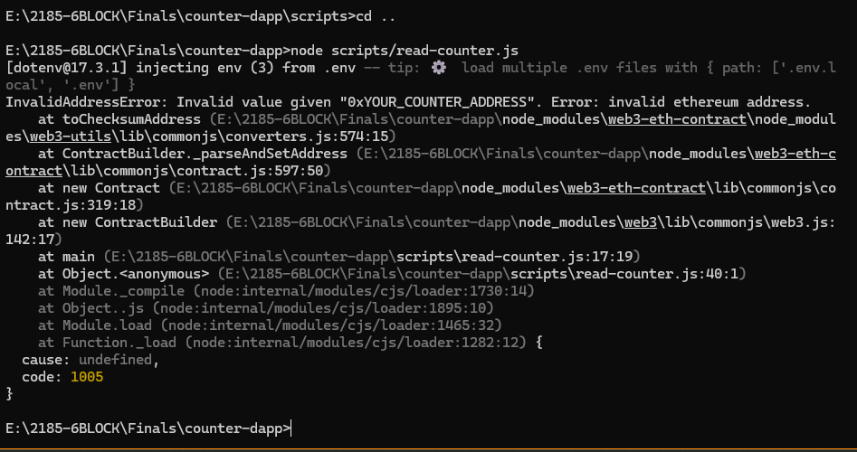

Activity 4.2 — Write to the Contract with Web3.js

🌐 WEB3.JS
Writing to a contract (state-changing functions) requires a wallet. In Node.js, Web3.js signs transactions using a private key directly. In the browser, it uses MetaMask. We use the private key approach here.

4 | Send a Transaction — Increment the Counter  Create scripts/write-counter.js:  1 // scripts/write-counter.js  2 // Run with: node scripts/write-counter.js  3  4 const { Web3 } = require("web3");  5 require("dotenv").config();  6 const { COUNTER_ABI } = require("./abi");  7  8 const RPC_URL = process.env.SEPOLIA_RPC_URL;  9 const PRIV_KEY = process.env.PRIVATE_KEY;  10 const CONTRACT = '0xYOUR_COUNTER_ADDRESS';  11  12 async function main() {  13 const web3 = new Web3(RPC_URL);  14  15 // Add your account to Web3's wallet so it can sign  16 const account = web3.eth.accounts.privateKeyToAccount(PRIV_KEY);  17 web3.eth.accounts.wallet.add(account);  18 const FROM = account.address;  19  20 const counter = new web3.eth.Contract(COUNTER_ABI, CONTRACT);  21  22 // Read count BEFORE  23 const before = await counter.methods.count().call();  24 console.log('Count BEFORE:', before.toString());  25  26 // Estimate gas — always do this before sending  27 const gasEstimate = await counter.methods  28 .increment()  29 .estimateGas({ from: FROM });  30 console.log('Estimated gas:', gasEstimate.toString());  31  32 // Send the transaction  33 console.log('Sending increment() transaction...');  34 const receipt = await counter.methods  35 .increment()  36 .send({  37 from: FROM,  38 gas: Math.ceil(Number(gasEstimate) * 1.2), // 20% buffer  39 });  40  41 console.log('Tx hash:', receipt.transactionHash);  42 console.log('Block: ', receipt.blockNumber.toString());  43 console.log('Gas used:', receipt.gasUsed.toString());  44  45 // Read count AFTER  46 const after = await counter.methods.count().call();  47 console.log('Count AFTER:', after.toString());  48  49 // Decode the emitted event from the receipt  50 const events = receipt.events?.CountIncremented;  51 if (events) {  52 console.log('Event — by:', events.returnValues.by);  53 console.log('Event — newCount:', events.returnValues.newCount.toString());  54 }  55 }  56  57 main().catch(console.error);  Run it:  1 node scripts/write-counter.js  What to Look For Your Observation  Count BEFORE  Estimated gas  Transaction hash  Count AFTER  Event 'newCount' value
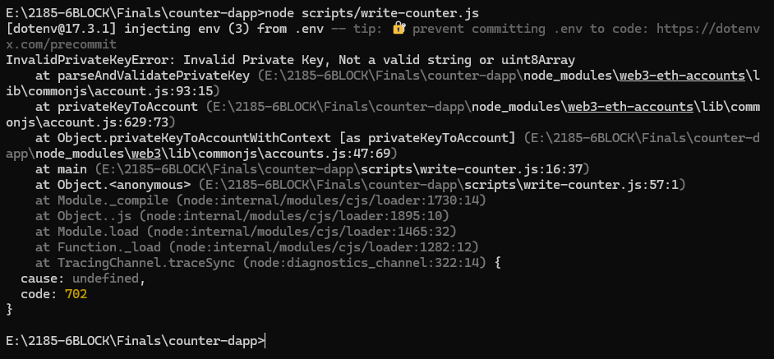
5 | Listen for Past Events  Create scripts/events-counter.js to read all past CountIncremented events:  1 // scripts/events-counter.js  2 const { Web3 } = require("web3");  3 require("dotenv").config();  4 const { COUNTER_ABI } = require("./abi");  5  6 const RPC_URL = process.env.SEPOLIA_RPC_URL;  7 const CONTRACT = '0xYOUR_COUNTER_ADDRESS';  8  9 async function main() {  10 const web3 = new Web3(RPC_URL);  11 const counter = new web3.eth.Contract(COUNTER_ABI, CONTRACT);  12  13 // Fetch all CountIncremented events from block 0 to latest  14 const events = await counter.getPastEvents(  15 'CountIncremented',  16 { fromBlock: 0, toBlock: 'latest' }  17 );  18  19 console.log(`Found ${events.length} CountIncremented event(s):`);  20 events.forEach((e, i) => {  21 console.log(` [${i+1}] block ${e.blockNumber}`,  22 '| by:', e.returnValues.by,  23 '| newCount:', e.returnValues.newCount.toString());  24 });  25 }  26  27 main().catch(console.error);  1 node scripts/events-counter.js  What to Look For Your Observation  Total number of CountIncremented events found  Block number of the first increment event  Address that sent the first increment
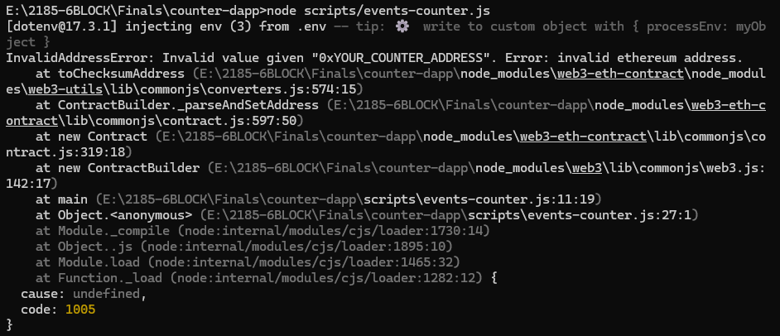
Q1 | In read-counter.js you used .call() and in write-counter.js you used .send(). What is the core difference between these two Web3.js methods? Which one requires gas? Which one needs a private key?
Q2 | The write script uses estimateGas() and then multiplies by 1.2 before sending. Why is the 20% buffer important? What happens if you send a transaction with less gas than the actual execution requires?
Q3 | In the browser (Part 5), you will use window.ethereum (MetaMask) instead of a private key to sign transactions. What security advantage does this have over embedding a private key in a Node.js script?

PART 5 REACT + WEB3.JS — BUILDING THE DAPP FRONTEND

Now you will build a React web application that connects to your deployed Counter contract via MetaMask and Web3.js. Users will be able to read the counter, increment it, and see live updates — all without touching a terminal.

What You Will Build

Feature | How It Works
Connect Wallet button | Calls window.ethereum.request to connect MetaMask
Live count display | Reads counter.methods.count().call() on load
Increment button | Sends counter.methods.increment().send() via MetaMask
Owner-only Reset | Checks msg.sender === owner before showing button
Transaction status | Shows pending / confirmed / error feedback
Event history | Reads past CountIncremented events and lists them

Activity 5.1 — Scaffold the React App

1 | Create the React Project  Inside your counter-dapp folder, create the React app in a frontend/ subfolder:  1 # From inside counter-dapp/  2 npm create vite@latest frontend -- --template react  3 cd frontend  4 npm install

2 | Install Web3.js  1 # Still inside counter-dapp/frontend/  2 npm install web3

3 | Fix the Vite Config for Web3.js  Web3.js uses Node.js globals. You must polyfill them for Vite. Open frontend/vite.config.js and replace its contents:  1 import { defineConfig } from "vite";  2 import react from "@vitejs/plugin-react";  3  4 export default defineConfig({  5 plugins: [react()],  6 define: {  7 // Web3.js requires this browser polyfill  8 global: 'globalThis',  9 },  10 });  🛑 STOP  Without global: 'globalThis', you will see 'ReferenceError: global is not defined' when Web3.js loads. This is the most common gotcha when using Web3.js with Vite.

4 | Create the Environment File  Inside frontend/, create a .env file:  1 # frontend/.env  2  3 # Your deployed Counter address from Part 2  4 VITE_CONTRACT_ADDRESS=0xYOUR_COUNTER_ADDRESS  5  6 # Public Sepolia RPC for read-only calls  7 VITE_SEPOLIA_RPC=https://rpc.sepolia.org  ⚠️ WARNING  In Vite, only variables starting with VITE_ are exposed to the browser. Never put your private key in a frontend .env file.

Activity 5.2 — Write the App Files
Create each file below exactly as shown. The project uses a flat structure for simplicity.

frontend/src/web3Service.js | Web3.js setup, ABI, contract instance, wallet helpers

1 | // web3Service.js — all blockchain interaction lives here
2 | import { Web3 } from "web3";
3
4 | // ── ABI ──────────────────────────────────────────────────────────
5 | // Sourced from artifacts/contracts/Counter.sol/Counter.json
6 | export const COUNTER_ABI = [
7 | {"inputs":[{"name":"_startCount","type":"uint256"},
8 | {"name":"_stepSize","type":"uint256"}],
9 | "stateMutability":"nonpayable","type":"constructor"},
10 | {"anonymous":false,"inputs":[{"indexed":true,"name":"by","type":"address"},
11 | {"indexed":false,"name":"newCount","type":"uint256"}],
12 | "name":"CountIncremented","type":"event"},
13 | {"anonymous":false,"inputs":[{"indexed":true,"name":"by","type":"address"}],
14 | "name":"CountReset","type":"event"},
15 | {"anonymous":false,"inputs":[{"indexed":false,"name":"count","type":"uint256"}],
16 | "name":"Milestone","type":"event"},
17 | {"inputs":[],"name":"count","outputs":[{"type":"uint256"}],
18 | "stateMutability":"view","type":"function"},
19 | {"inputs":[],"name":"owner","outputs":[{"type":"address"}],
20 | "stateMutability":"view","type":"function"},
21 | {"inputs":[],"name":"stepSize","outputs":[{"type":"uint256"}],
22 | "stateMutability":"view","type":"function"},
23 | {"inputs":[],"name":"increment","outputs":[],
24 | "stateMutability":"nonpayable","type":"function"},
25 | {"inputs":[],"name":"reset","outputs":[],
26 | "stateMutability":"nonpayable","type":"function"},
27 | {"inputs":[{"name":"_newStep","type":"uint256"}],"name":"setStepSize",
28 | "outputs":[],"stateMutability":"nonpayable","type":"function"},
29 | {"inputs":[{"name":"_target","type":"uint256"}],"name":"hasReachedTarget",
30 | "outputs":[{"type":"bool"}],"stateMutability":"view","type":"function"}
31 | ];
32
33 | export const CONTRACT_ADDRESS = import.meta.env.VITE_CONTRACT_ADDRESS;
34 | const SEPOLIA_RPC = import.meta.env.VITE_SEPOLIA_RPC || 'https://rpc.sepolia.org';
35
36 | // ── Read-only Web3 instance (uses public RPC) ─────────────────────
37 | export const web3 = new Web3(SEPOLIA_RPC);
38
39 | // ── Read-only contract instance ───────────────────────────────────
40 | export const counterContract = new web3.eth.Contract(
41 | COUNTER_ABI,
42 | CONTRACT_ADDRESS
43 | );
44
45 | // ── Connect MetaMask and return signer web3 + account ─────────────
46 | export async function connectWallet() {
47 | if (!window.ethereum) {
48 | throw new Error("MetaMask not installed. Please install it first.");
49 | }
50 | // Request wallet access — MetaMask pops up
51 | const accounts = await window.ethereum.request({
52 | method: "eth_requestAccounts",
53 | });
54 | const account = accounts[0];
55
56 | // Create a Web3 instance backed by MetaMask
57 | const mmWeb3 = new Web3(window.ethereum);
58
59 | // Make sure user is on Sepolia (chain ID 11155111 = 0xAA36A7)
60 | const chainId = await mmWeb3.eth.getChainId();
61 | if (chainId !== 11155111n) {
62 | try {
63 | // Ask MetaMask to switch
64 | await window.ethereum.request({
65 | method: "wallet_switchEthereumChain",
66 | params: [{ chainId: "0xAA36A7" }],
67 | });
68 | } catch {
69 | throw new Error("Please switch MetaMask to Sepolia Testnet.");
70 | }
71 | }
72
73 | return { mmWeb3, account };
74 | }
75
76 | // ── Get a write-enabled contract instance ─────────────────────────
77 | export function getWriteContract(mmWeb3) {
78 | return new mmWeb3.eth.Contract(COUNTER_ABI, CONTRACT_ADDRESS);
79 | }
80
81 | // ── Fetch past events ─────────────────────────────────────────────
82 | export async function fetchEvents() {
83 | const events = await counterContract.getPastEvents(
84 | "CountIncremented",
85 | { fromBlock: 0, toBlock: 'latest' }
86 | );
87 | return events.map(e => ({
88 | by: e.returnValues.by,
89 | newCount: e.returnValues.newCount.toString(),
90 | block: e.blockNumber.toString(),
91 | }));
92 | }

frontend/src/index.css | Global styles — dark theme

1 | *, *::before, *::after { box-sizing: border-box; margin: 0; padding: 0; }
2
3 | :root {
4 | --bg: #0d1117;
5 | --bg2: #161b22;
6 | --bg3: #21262d;
7 | --border: #30363d;
8 | --accent: #58a6ff;
9 | --green: #3fb950;
10 | --red: #f85149;
11 | --amber: #d29922;
12 | --text: #e6edf3;
13 | --text2: #8b949e;
14 | --mono: 'Courier New', monospace;
15 | --radius: 10px;
16 | }
17 | body { background:var(--bg); color:var(--text);
18 | font-family:'Segoe UI',system-ui,sans-serif; min-height:100vh; }
19 | .card { background:var(--bg2); border:1px solid var(--border);
20 | border-radius:var(--radius); padding:1.5rem; }
21 | button { font-family:inherit; cursor:pointer; border:none;
22 | border-radius:6px; transition:all .15s; font-weight:600; }
23 | button:disabled { opacity:.4; cursor:not-allowed; }
24 | .btn-primary { background:var(--accent); color:#000; padding:.6rem 1.4rem; font-size:.85rem; }
25 | .btn-primary:hover:not(:disabled) { background:#79b8ff; }
26 | .btn-secondary { background:transparent; color:var(--text); border:1px solid var(--border);
27 | padding:.6rem 1.4rem; font-size:.85rem; }
28 | .btn-secondary:hover:not(:disabled) { border-color:var(--accent); color:var(--accent); }
29 | .btn-danger { background:transparent; color:var(--red); border:1px solid var(--red);
30 | padding:.55rem 1.2rem; font-size:.82rem; }
31 | .btn-danger:hover:not(:disabled) { background:rgba(248,81,73,.1); }
32 | .badge { font-family:var(--mono); font-size:.7rem; padding:.2rem .6rem;
33 | border-radius:999px; font-weight:700; }
34 | .badge-ok { background:rgba(63,185,80,.1); color:var(--green);
35 | border:1px solid rgba(63,185,80,.3); }
36 | .badge-net { background:rgba(88,166,255,.1); color:var(--accent);
37 | border:1px solid rgba(88,166,255,.3); }
38 | .badge-err { background:rgba(248,81,73,.1); color:var(--red);
39 | border:1px solid rgba(248,81,73,.3); }
40 | .badge-pending { background:rgba(210,153,34,.1); color:var(--amber);
41 | border:1px solid rgba(210,153,34,.3); }
42 | .mono { font-family:var(--mono); font-size:.8rem; color:var(--text2); }
43 | .toast { position:fixed; bottom:1.5rem; right:1.5rem; padding:.9rem 1.3rem;
44 | border-radius:var(--radius); border:1px solid; font-size:.85rem;
45 | max-width:340px; animation:slide-in .25s ease; z-index:99; }
46 | .toast-ok { background:rgba(63,185,80,.1); border-color:rgba(63,185,80,.4);
47 | color:var(--green); }
48 | .toast-err { background:rgba(248,81,73,.1); border-color:rgba(248,81,73,.4);
49 | color:var(--red); }
50 | .toast-info{ background:rgba(88,166,255,.1); border-color:rgba(88,166,255,.4);
51 | color:var(--accent); }
52 | @keyframes slide-in { from{transform:translateX(110%)}to{transform:translateX(0)} }
53 | .spinner { display:inline-block; width:13px; height:13px;
54 | border:2px solid transparent; border-top-color:currentColor;
55 | border-radius:50%; animation:spin .6s linear infinite; }
56 | @keyframes spin { to{transform:rotate(360deg)} }

frontend/src/App.jsx | Root component — wires everything together

1 | import { useState, useEffect, useCallback } from 'react';
2 | import Header from './components/Header.jsx';
3 | import CounterCard from './components/CounterCard.jsx';
4 | import EventLog from './components/EventLog.jsx';
5 | import { counterContract, fetchEvents } from './web3Service.js';
6
7 | export default function App() {
8 | const [account, setAccount] = useState(null);
9 | const [mmWeb3, setMmWeb3] = useState(null);
10 | const [count, setCount] = useState('...');
11 | const [owner, setOwner] = useState(null);
12 | const [stepSize,setStepSize] = useState('1');
13 | const [events, setEvents] = useState([]);
14 | const [toast, setToast] = useState(null);
15
16 | const showToast = useCallback((msg, type='info') => {
17 | setToast({ msg, type });
18 | setTimeout(() => setToast(null), 4500);
19 | }, []);
20
21 | // Load contract state
22 | const refresh = useCallback(async () => {
23 | try {
24 | const [c, o, s] = await Promise.all([
25 | counterContract.methods.count().call(),
26 | counterContract.methods.owner().call(),
27 | counterContract.methods.stepSize().call(),
28 | ]);
29 | setCount(c.toString());
30 | setOwner(o);
31 | setStepSize(s.toString());
32 | const evts = await fetchEvents();
33 | setEvents(evts.reverse().slice(0, 10));
34 | } catch (e) {
35 | showToast('Failed to load contract data: ' + e.message, 'err');
36 | }
37 | }, [showToast]);
38
39 | useEffect(() => { refresh(); }, [refresh]);
40
41 | const handleConnect = (acc, web3) => {
42 | setAccount(acc);
43 | setMmWeb3(web3);
44 | showToast('Wallet connected!', 'ok');
45 | };
46
47 | const isOwner = account && owner &&
48 | account.toLowerCase() === owner.toLowerCase();
49
50 | return (
51 | <div style={{ minHeight:'100vh' }}>
52 | <Header account={account} onConnect={handleConnect}
53 | showToast={showToast} />
54 | <main style={{
55 | maxWidth:900, margin:'0 auto', padding:'2rem 1.25rem',
56 | display:'grid', gap:'1.5rem'
57 | }}>
58 | <CounterCard
59 | count={count} stepSize={stepSize}
60 | account={account} mmWeb3={mmWeb3}
61 | isOwner={isOwner} onRefresh={refresh}
62 | showToast={showToast} />
63 | <EventLog events={events} onRefresh={refresh} />
64 | </main>
65 | {toast && (
66 | <div className={`toast toast-${toast.type}`}>
67 | {toast.type==='ok'?'✓ ':toast.type==='err'?'✕ ':'ℹ '}
68 | {toast.msg}
69 | </div>
70 | )}
71 | </div>
72 | );
73 | }

frontend/src/components/Header.jsx | Top bar with MetaMask connect button

Create the folder frontend/src/components/, then create Header.jsx:

1 | import { connectWallet } from '../web3Service.js';
2
3 | export default function Header({ account, onConnect, showToast }) {
4 | const short = a => a ? `${a.slice(0,6)}…${a.slice(-4)}` : null;
5
6 | const handleConnect = async () => {
7 | try {
8 | const { mmWeb3, account } = await connectWallet();
9 | onConnect(account, mmWeb3);
10 | } catch (e) {
11 | showToast(e.message, 'err');
12 | }
13 | };
14
15 | return (
16 | <header style={{
17 | borderBottom:'1px solid var(--border)',
18 | background:'rgba(13,17,23,.92)',
19 | backdropFilter:'blur(10px)',
20 | position:'sticky', top:0, zIndex:50,
21 | }}>
22 | <div style={{
23 | maxWidth:900, margin:'0 auto',
24 | display:'flex', alignItems:'center',
25 | justifyContent:'space-between', height:62, padding:'0 1.25rem',
26 | }}>
27 | <div style={{display:'flex',alignItems:'center',gap:'.6rem'}}>
28 | <span style={{fontSize:'1.3rem'}}>⚡</span>
29 | <span style={{fontWeight:800,fontSize:'1.05rem'}}>
30 | Counter<span style={{color:'var(--accent)'}}>DApp</span>
31 | </span>
32 | <span className='badge badge-net'>SEPOLIA</span>
33 | </div>
34 | {account ? (
35 | <span className='badge badge-ok'>● {short(account)}</span>
36 | ) : (
37 | <button className='btn-primary' onClick={handleConnect}>
38 | Connect MetaMask
39 | </button>
40 | )}
41 | </div>
42 | </header>
43 | );
44 | }

frontend/src/components/CounterCard.jsx | Main counter UI — read, increment, reset

1 | import { useState } from 'react';
2 | import { getWriteContract } from '../web3Service.js';
3
4 | export default function CounterCard({
5 | count, stepSize, account, mmWeb3,
6 | isOwner, onRefresh, showToast,
7 | }) {
8 | const [txStatus, setTxStatus] = useState(null); // null|'pending'|'done'|'err'
9 | const [newStep, setNewStep] = useState('');
10
11 | // Generic send helper
12 | const send = async (label, fn) => {
13 | if (!account || !mmWeb3)
14 | return showToast('Connect your wallet first', 'err');
15 | setTxStatus('pending');
16 | showToast(`${label}: submitted to MetaMask…`, 'info');
17 | try {
18 | const contract = getWriteContract(mmWeb3);
19 | const gasEst = await fn(contract).estimateGas({ from: account });
20 | const receipt = await fn(contract).send({
21 | from: account,
22 | gas: Math.ceil(Number(gasEst) * 1.2),
23 | });
24 | showToast(`${label}: confirmed in block ${receipt.blockNumber}`, 'ok');
25 | setTxStatus('done');
26 | setTimeout(onRefresh, 1500);
27 | } catch (e) {
28 | const msg = e?.cause?.message || e?.message || 'Transaction failed';
29 | showToast(msg.slice(0,80), 'err');
30 | setTxStatus('err');
31 | }
32 | setTimeout(() => setTxStatus(null), 4000);
33 | };
34
35 | const statusBadge = txStatus && (
36 | <span className={`badge badge-${txStatus==='pending'?'pending':txStatus==='done'?'ok':'err'}`}>
37 | {txStatus==='pending'?<><span className='spinner'/> Pending</>
38 | :txStatus==='done'?'✓ Confirmed':'✕ Failed'}
39 | </span>
40 | );
41
42 | return (
43 | <div className='card'>
44 | <div style={{display:'flex',justifyContent:'space-between',
45 | alignItems:'flex-start',marginBottom:'1.5rem',flexWrap:'wrap',gap:'.5rem'}}>
46 | <div>
47 | <h1 style={{fontSize:'1.1rem',fontWeight:700,marginBottom:'.25rem'}}>
48 | Counter Contract
49 | </h1>
50 | <p className='mono'>step size: {stepSize}</p>
51 | </div>
52 | {statusBadge}
53 | </div>
54
55 | {/* Big count display */}
56 | <div style={{
57 | textAlign:'center', padding:'2.5rem 1rem',
58 | background:'var(--bg3)', borderRadius:8, marginBottom:'1.5rem',
59 | }}>
60 | <div style={{
61 | fontFamily:'var(--mono)', fontSize:'5rem',
62 | fontWeight:900, color:'var(--accent)',
63 | lineHeight:1, marginBottom:'.5rem',
64 | }}>{count}</div>
65 | <div style={{color:'var(--text2)',fontSize:'.85rem'}}>
66 | current count on Sepolia
67 | </div>
68 | </div>
69
70 | {/* Action buttons */}
71 | <div style={{display:'flex',gap:'.75rem',flexWrap:'wrap',marginBottom:'1.5rem'}}>
72 | <button className='btn-primary' style={{flex:1}}
73 | disabled={!account || txStatus==='pending'}
74 | onClick={() => send('increment', c => c.methods.increment())}>
75 | {txStatus==='pending' ? <span className='spinner'/> : '＋'} Increment
76 | </button>
77 | <button className='btn-secondary'
78 | disabled={txStatus==='pending'}
79 | onClick={onRefresh}>↻ Refresh
80 | </button>
81 | {isOwner && (
82 | <button className='btn-danger'
83 | disabled={txStatus==='pending'}
84 | onClick={() => send('reset', c => c.methods.reset())}>
85 | Reset to 0
86 | </button>
87 | )}
88 | </div>
89
90 | {/* Owner: change step size */}
91 | {isOwner && (
92 | <div style={{
93 | borderTop:'1px solid var(--border)',paddingTop:'1rem',
94 | display:'flex',gap:'.75rem',alignItems:'center',
95 | }}>
96 | <span style={{color:'var(--text2)',fontSize:'.85rem',whiteSpace:'nowrap'}}>
97 | Change step size:
98 | </span>
99 | <input
100 | type='number' value={newStep} placeholder={stepSize}
101 | onChange={e => setNewStep(e.target.value)}
102 | style={{
103 | background:'var(--bg3)',border:'1px solid var(--border)',
104 | color:'var(--text)',borderRadius:6,padding:'.4rem .6rem',
105 | width:80,fontFamily:'var(--mono)',fontSize:'.85rem',outline:'none',
106 | }}
107 | />
108 | <button className='btn-secondary' style={{fontSize:'.8rem'}}
109 | disabled={!newStep||txStatus==='pending'}
110 | onClick={() => send(
111 | 'setStepSize',
112 | c => c.methods.setStepSize(Number(newStep))
113 | )}>
114 | Apply
115 | </button>
116 | </div>
117 | )}
118 | </div>
119 | );
120 | }

frontend/src/components/EventLog.jsx | Displays past CountIncremented events

1 | export default function EventLog({ events, onRefresh }) {
2 | return (
3 | <div className='card'>
4 | <div style={{display:'flex',justifyContent:'space-between',
5 | alignItems:'center',marginBottom:'1rem'}}>
6 | <h2 style={{fontWeight:700,fontSize:'1rem'}}>
7 | Recent Increment Events
8 | </h2>
9 | <button className='btn-secondary'
10 | style={{fontSize:'.75rem',padding:'.3rem .75rem'}}
11 | onClick={onRefresh}>↻ Refresh
12 | </button>
13 | </div>
14
15 | {events.length === 0 ? (
16 | <p style={{color:'var(--text2)',fontSize:'.85rem',textAlign:'center',
17 | padding:'2rem 0'}}>
18 | No events yet. Increment the counter to see activity.
19 | </p>
20 | ) : (
21 | <div style={{display:'flex',flexDirection:'column',gap:'.5rem'}}>
22 | {events.map((e, i) => (
23 | <div key={i} style={{
24 | display:'flex',justifyContent:'space-between',
25 | alignItems:'center',padding:'.6rem .75rem',
26 | background:'var(--bg3)',borderRadius:6,
27 | flexWrap:'wrap',gap:'.5rem',
28 | }}>
29 | <div>
30 | <span style={{
31 | fontFamily:'var(--mono)',fontSize:'1rem',
32 | fontWeight:700,color:'var(--accent)',
33 | }}>
34 | {e.newCount}
35 | </span>
36 | <span style={{color:'var(--text2)',
37 | fontSize:'.72rem',marginLeft:'.5rem'}}>
38 | block #{e.block}
39 | </span>
40 | </div>
41 | <span className='mono' style={{fontSize:'.7rem'}}>
42 | {e.by.slice(0,8)}…{e.by.slice(-6)}
43 | </span>
44 | </div>
45 | ))}
46 | </div>
47 | )}
48 | </div>
49 | );
50 | }

frontend/src/main.jsx | Entry point — replace existing content

1 | import React from 'react';
2 | import ReactDOM from 'react-dom/client';
3 | import App from './App.jsx';
4 | import './index.css';
5
6 | ReactDOM.createRoot(document.getElementById('root')).render(
7 | <React.StrictMode>
8 | <App />
9 | </React.StrictMode>
10 | );

Activity 5.3 — Run the DApp Locally

5 | Start the Dev Server  In your terminal, navigate to frontend/ and start Vite:  1 cd frontend  2 npm run dev  Expected output:  1 VITE v5.x.x ready in 400ms  2 ➜ Local: http://localhost:5173/  Open http://localhost:5173 in your browser. You should see the CounterDApp homepage with the current count loaded from Sepolia.

6 | Test the Full Flow  - Click Connect MetaMask — approve the connection in the MetaMask popup  - Verify your address appears in the header as a green ● badge  - Note the current count displayed  - Click ＋ Increment — MetaMask pops up with the gas estimate  - Click Confirm in MetaMask  - Watch for the 'Pending' badge → '✓ Confirmed' badge  - After ~15 seconds the count updates and a new event appears in the log  - If you are the owner, test Reset to 0 and Change step size  What to Look For Your Observation  Count displayed on page load  Count after clicking Increment  Transaction hash shown in toast  Event entry in the event log  Did the Reset button appear? (Owner only)
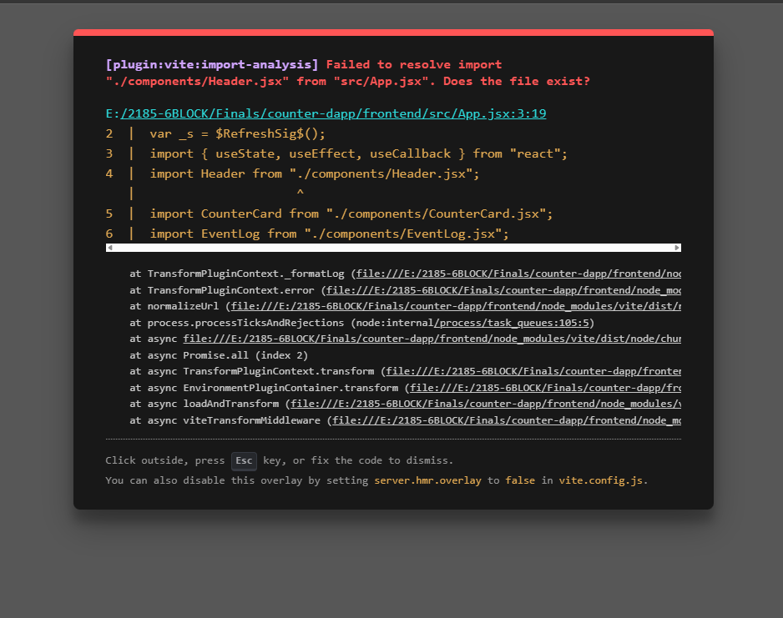
PART 6 DEPLOYING THE REACT APP — VERCEL & NETLIFY

Your DApp currently runs only on your computer. To make it accessible to anyone in the world, you need to deploy the frontend to a hosting service. Both Vercel and Netlify offer free tiers that are perfect for DApps.

Activity 6.1 — Build for Production

1 | Run the Production Build  Inside the frontend/ folder:  1 npm run build  Vite bundles your React app into static files in the dist/ folder:  1 frontend/  2 └── dist/  3 ├── index.html  4 ├── assets/  5 │ ├── index-XXXXXX.js ← all JS bundled and minified  6 │ └── index-XXXXXX.css ← all CSS bundled  7 └── ...  Preview the production build locally before deploying:  1 npm run preview  2 # Opens at http://localhost:4173  💡 TIP  Always preview the production build before deploying. Errors that only appear in production mode (not dev mode) will show up here first.

Activity 6.2 — Deploy to Vercel

Vercel is the easiest way to deploy a Vite React app. It reads your project, detects Vite automatically, and deploys in seconds.

2 | Push to GitHub First  Vercel deploys from a GitHub repository. Initialize Git if you haven't already:  1 # From the counter-dapp/ root:  2 git init  3 git add .  4 git commit -m 'Initial commit — Counter DApp'  Then create a new repository on https://github.com and push:  1 git remote add origin https://github.com/YOUR_USERNAME/counter-dapp.git  2 git branch -M main  3 git push -u origin main  🛑 STOP  IMPORTANT: Make sure your .env files are in .gitignore before pushing. Your private key must never appear in a public GitHub repository.

3 | Deploy on Vercel  - Go to https://vercel.com and sign up with your GitHub account  - Click Add New Project → select your counter-dapp repository  - Vercel will detect Vite. Under Root Directory, change it to frontend — this is important!  - Expand Environment Variables and add both:  Variable Name Value  VITE_CONTRACT_ADDRESS 0xYOUR_DEPLOYED_COUNTER_ADDRESS  VITE_SEPOLIA_RPC https://rpc.sepolia.org  - Click Deploy — Vercel builds and deploys in ~30 seconds  - When finished, click your live URL — it looks like: counter-dapp-abc123.vercel.app  💡 TIP  Every time you push a new commit to GitHub, Vercel automatically rebuilds and redeploys. This is called continuous deployment (CD).

Activity 6.3 — Deploy to Netlify (Alternative)

Netlify is an equally popular option. You can deploy directly by dragging the dist/ folder — no GitHub account needed.

4 | Option A — Drag-and-Drop Deploy  - Go to https://netlify.com and sign up for a free account  - Click Add new site → Deploy manually  - Drag your frontend/dist/ folder into the Netlify deploy area  - Netlify gives you an instant URL — your DApp is live  📌 NOTE  With drag-and-drop, your VITE_ environment variables are baked into the build at build time. Make sure your dist/ was built with the correct .env values before dragging.

5 | Option B — GitHub + Netlify (Recommended)  - In Netlify, click Add new site → Import an existing project → Connect to GitHub  - Select your counter-dapp repository  - Configure the build settings:  Setting Value  Base directory frontend  Build command npm run build  Publish directory frontend/dist  - Click Show advanced → add the same environment variables as Vercel above  - Click Deploy site

Post-Deployment Verification

After deploying, run through this checklist on the live URL:

✓ | Check
☐ | Page loads with the correct count from Sepolia
☐ | Connect MetaMask works on the live site
☐ | Increment sends a real transaction and count updates
☐ | Event log shows past increments
☐ | Share the URL with a classmate — they can increment from their wallet
☐ | Transaction appears on Sepolia Etherscan

What to Look For | Your Observation
Your live DApp URL (Vercel or Netlify)
Count on the live site matches Etherscan?
Classmate's wallet address who tested your DApp

Q1 | Your React DApp reads from Sepolia using a public RPC URL (https://rpc.sepolia.org). For a production app with many users, why might you want to use a private RPC from Alchemy or Infura instead of a public one?
Q2 | When you built for production with 'npm run build', Vite bundled all your code into a single JS file. Your VITE_CONTRACT_ADDRESS is baked into this file. If you need to change the contract address later, what do you have to do?
Q3 | The DApp only works if the user has MetaMask installed. What would you show a user who visits the site without MetaMask? How does your Header.jsx currently handle this situation?
Q4 | You deployed a frontend DApp but the backend (the smart contract) is already deployed and immutable on Sepolia. What does this mean for maintenance? If you find a bug in Counter.sol, can you 'patch' it? What would you have to do instead?

REFERENCE QUICK REFERENCE — ALL COMMANDS, FILES & URLS

Project File Structure

1 | counter-dapp/
2 | ├── contracts/
3 | │ └── Counter.sol
4 | ├── ignition/modules/
5 | │ └── Counter.js
6 | ├── scripts/
7 | │ ├── abi.js
8 | │ ├── read-counter.js
9 | │ ├── write-counter.js
10 | │ └── events-counter.js
11 | ├── hardhat.config.js
12 | ├── .env ← NEVER commit
13 | ├── .gitignore
14 | └── frontend/
15 | ├── src/
16 | │ ├── main.jsx
17 | │ ├── App.jsx
18 | │ ├── index.css
19 | │ ├── web3Service.js
20 | │ └── components/
21 | │ ├── Header.jsx
22 | │ ├── CounterCard.jsx
23 | │ └── EventLog.jsx
24 | ├── index.html
25 | ├── vite.config.js
26 | ├── .env ← VITE_ vars only
27 | └── package.json

All Commands in Order

# | Command | What It Does
1 | npx hardhat init | Scaffold project
2 | npx hardhat compile | Compile contracts → artifacts/
3 | npx hardhat test | Run test suite
4 | npx hardhat node | Start local blockchain
5 | npx hardhat ignition deploy ... --network sepolia | Deploy to Sepolia
6 | npx hardhat verify --network sepolia <addr> 0 1 | Verify on Etherscan
7 | node scripts/read-counter.js | Read contract state
8 | node scripts/write-counter.js | Send increment tx
9 | node scripts/events-counter.js | Fetch past events
10 | npm create vite@latest frontend -- --template react | Create React app
11 | npm install web3 | Install Web3.js in frontend
12 | npm run dev (in frontend/) | Start Vite dev server
13 | npm run build (in frontend/) | Build for production
14 | npm run preview (in frontend/) | Preview production build

Web3.js Cheat Sheet

Operation | Code
Connect to RPC | const web3 = new Web3(rpcUrl)
Connect MetaMask | const web3 = new Web3(window.ethereum)
Create contract (read) | new web3.eth.Contract(abi, address)
Call view function | await contract.methods.fn(args).call()
Send transaction | await contract.methods.fn(args).send({from})
Estimate gas | await contract.methods.fn(args).estimateGas({from})
Get past events | contract.getPastEvents('Name',{fromBlock:0,toBlock:'latest'})
Request MetaMask accounts | window.ethereum.request({method:'eth_requestAccounts'})
Get chain ID | await web3.eth.getChainId()
ETH to Wei | web3.utils.toWei('1','ether')
Wei to ETH | web3.utils.fromWei(n,'ether')

Troubleshooting

Problem | Cause | Fix
global is not defined | Vite missing polyfill | Add global:'globalThis' to vite.config.js define
MetaMask not installed | No browser extension | Show error message, link to metamask.io
Wrong network error | MetaMask on mainnet | connectWallet() calls wallet_switchEthereumChain
Transaction rejected by user | User clicked Reject in MetaMask | Catch error, show toast, do not crash the app
Count doesn't update after tx | Refresh called too early | Use setTimeout(refresh, 1500) after receipt
Events list empty | Contract not deployed yet | Check VITE_CONTRACT_ADDRESS in .env
Build fails — VITE_* undefined | .env not in frontend/ folder | Create frontend/.env not root .env
Vercel: wrong directory | Root set to counter-dapp/ | Set Root Directory to 'frontend' in Vercel

Important URLs

Resource | URL
Sepolia Etherscan | https://sepolia.etherscan.io
Alchemy (RPC) | https://www.alchemy.com
Etherscan API Keys | https://etherscan.io/myapikey
Sepolia Faucet | https://sepoliafaucet.com
MetaMask | https://metamask.io
Node.js | https://nodejs.org
Hardhat Docs | https://hardhat.org/docs
Web3.js Docs | https://docs.web3js.org
Vercel | https://vercel.com
Netlify | https://netlify.com

Final Lab Submission Checklist

✓ | Deliverable
☐ | MetaMask set up with Sepolia, Sepolia ETH received
☐ | Counter.sol compiled — green checkmark in terminal
☐ | Counter.sol deployed to Sepolia — address recorded
☐ | Contract verified on Sepolia Etherscan — green ✓ shown
☐ | read-counter.js runs successfully — output screenshot
☐ | write-counter.js sends increment tx — Txn Hash recorded
☐ | events-counter.js shows event history
☐ | React app runs at localhost:5173 — screenshot
☐ | Connected MetaMask in the browser, count displayed
☐ | Sent increment from the React UI — count updated
☐ | DApp deployed to Vercel or Netlify — live URL shared
☐ | Classmate successfully used your live DApp
☐ | All discussion questions answered

